Ȭ

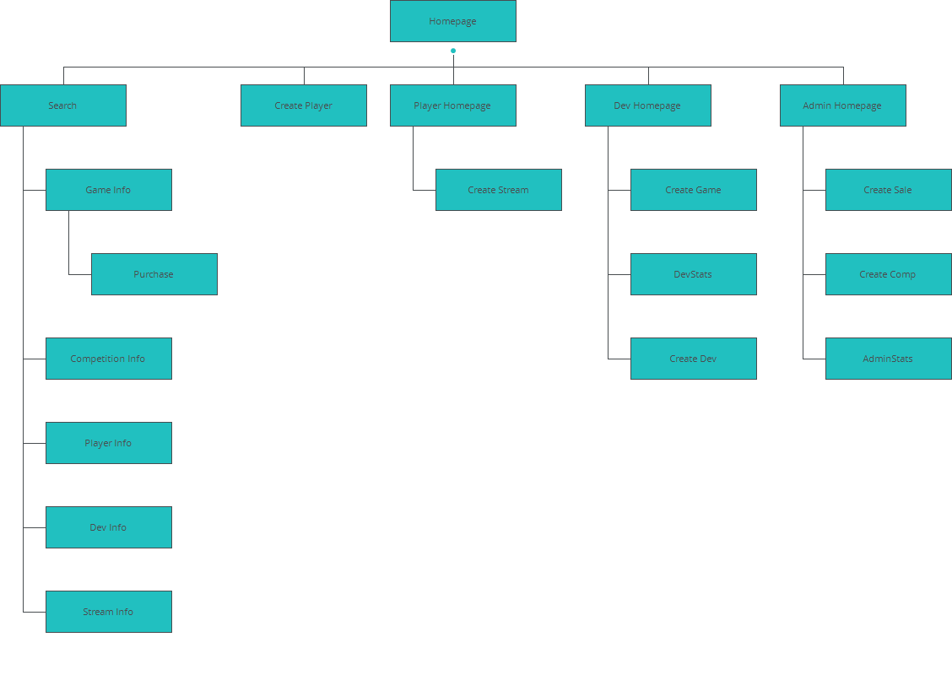

Dev Homepage

|  |
| --- |
|  |

Interactions

|  |  |
| --- | --- |
| 1 | **on Click:** goes to 'Create Game' 🡪 |
| 2 | **on Click:** goes to 'DevStats' 🡪 |
| 3 | **on Click:** goes to 'Homepage' 🡪 |
| 4 | **on Click:** goes to 'Create Dev' 🡪 |

Player Homepage

|  |
| --- |
|  |

Interactions

|  |  |
| --- | --- |
| 5 | **on Click:** goes to 'Create Player' 🡪 |
| 6 | **on Click:** goes to 'Create Stream' 🡪 |

Admin Homepage

|  |
| --- |
|  |

Interactions

|  |  |
| --- | --- |
| 7 | **on Click:** goes to 'Create Sale' 🡪 |
| 8 | **on Click:** goes to 'Create Comp' 🡪 |
| 9 | **on Click:** goes to 'Create Dev' 🡪 |
| 10 | **on Click:** goes to 'Create Player' 🡪 |
| 11 | **on Click:** goes to 'Create Player' 🡪 |
| 12 | **on Click:** goes to 'AdminStats' 🡪 |

Homepage

|  |
| --- |
|  |

Interactions

|  |  |
| --- | --- |
| 13 | **on Mouse Over:** changes style of 'rectangle_2': background color 🡪  **on Mouse Down:** changes style of 'rectangle_2': background color 🡪  **on Mouse Up:** changes style of 'rectangle_2': background color 🡪  **on Click:** goes to 'Search' 🡪 |

Search

|  |
| --- |
|  |

Interactions

|  |  |
| --- | --- |
| 14 | **on Click:** When ((selSearch.selected = 'Games') or (selSearch.selected = 'Sales')) goes to 'Game Info' 🡪 Else when (selSearch.selected = 'Competitions') goes to 'Competition Info' 🡪 Else when ((selSearch.selected = 'Players') or (selSearch.selected = 'Admins')) goes to 'Player Info' 🡪 Else when (selSearch.selected = 'Developers') goes to 'Dev Info' 🡪 Else when (selSearch.selected = 'Streams') goes to 'Stream Info' 🡪 |
| 15 | **on Click:** moves 'Ellipse_7' to x: -27px, y: current value with easing: swing in 300ms 🡪 sets active panel 'Panel_2' 🡪 moves 'Ellipse_7' to x: 33px, y: current value 🡪 |

|  |  |  |  |
| --- | --- | --- | --- |
|  | Interactions   |  |  | | --- | --- | | 16 | **on Click:** moves 'Ellipse_8' to x: 33px, y: current value with easing: swing in 300ms 🡪 sets active panel 'Panel_1' 🡪 moves 'Ellipse_8' to x: 4px, y: current value 🡪 | |

Game Info

|  |
| --- |
|  |

Interactions

|  |  |
| --- | --- |
| 17 | **on Click:** goes to 'Purchase' 🡪 |

Competition Info

|  |
| --- |
|  |

Interactions

|  |  |
| --- | --- |
| 19 | **on Page Load:** When (Permission = '3') shows 'Rectangle_3, Rectangle_4' 🡪 |

Player Info

|  |
| --- |
|  |

Interactions

|  |  |
| --- | --- |
| 20 | **on Click:** goes to 'Create Player' 🡪 |

Dev Info

|  |
| --- |
|  |

Stream Info

|  |
| --- |
|  |

Purchase

|  |
| --- |
|  |

Interactions

|  |  |
| --- | --- |
| 21 | **on Click:** goes to 'Player Homepage' 🡪 |

Create Player

|  |
| --- |
|  |

Interactions

|  |  |
| --- | --- |
| 22 | **on Click:** sets value '1' to variable(s) 'Permission' 🡪 goes to 'Player Homepage' 🡪 |

Create Game

|  |
| --- |
|  |

Interactions

|  |  |
| --- | --- |
| 23 | **on Click:** rotates 'arrow' by angle: 180º with easing: swing in 400ms 🡪 |
| 24 | **on Click:** rotates 'arrow' by angle: 180º with easing: swing in 400ms 🡪 |

Create Dev

|  |
| --- |
|  |

Interactions

|  |  |
| --- | --- |
| 25 | **on Page Load:** When (Permission <> '3') disables 'Input_4' 🡪 |

Create Sale

|  |
| --- |
|  |

Interactions

|  |  |
| --- | --- |
| 26 | **on Click:** goes to 'Competition Info' 🡪 |

Create Stream

|  |
| --- |
|  |

Interactions

|  |  |
| --- | --- |
| 27 | **on Click:** goes to 'Competition Info' 🡪 |

Create Comp

|  |
| --- |
|  |

Interactions

|  |  |
| --- | --- |
| 28 | **on Click:** goes to 'Competition Info' 🡪 |

AdminStats

|  |
| --- |
|  |

DevStats

|  |
| --- |
|  |

Login Template

|  |
| --- |
|  |

Interactions

|  |  |
| --- | --- |
| 32 | **on Click:** When (Permission <= '0') sets value '0' to variable(s) 'Permission' 🡪 goes to 'Homepage' 🡪 Else when (Permission = '1') goes to 'Player Homepage' 🡪 Else when (Permission = '2') goes to 'Dev Homepage' 🡪 Else when (Permission = '3') goes to 'Admin Homepage' 🡪 |
| 33 | **on Click:** goes to 'Search' 🡪 |
| 34 | **on Page Load:** When (Permission = '0') shows 'btnSignup, tBoxUsername, tBoxPassword, btnLogin' 🡪 Else when (Permission > '0') shows 'Rectangle_3, Image_35' 🡪 |